General tips for the Task below.
Task Title
AWS- Lambda ()
Objective
Worked on pre-requisite, as I performed R&D on the AWS-Lambda posted in DevOps group in slack as a requirement and task to work on below.
Prerequisites
List all requirements before starting:
- AWS-LAMBDA
Issues Faced: Briefly mention issues and how you fixed them. Posted below in the last.
Conclusion
Conclusion has been provided for every task at the end.

AWS-Lambda
What is AWS Lambda?
AWS Lambda is a serverless compute service that allows you to run code without provisioning or managing servers.
You upload your code, and AWS automatically handles infrastructure, scaling, and availability.
AWS Lambda = Serverless compute
That means:
- You run code without launching servers
- AWS handles infrastructure, scaling, patching
- You pay only for execution time, not uptime

Where will Lamda fits in:
For example:
In Traditional ec2 We manage servers → OS → scaling → pay 24/7
In Lambda Just upload code → triggers run it → auto scales → pay per ms

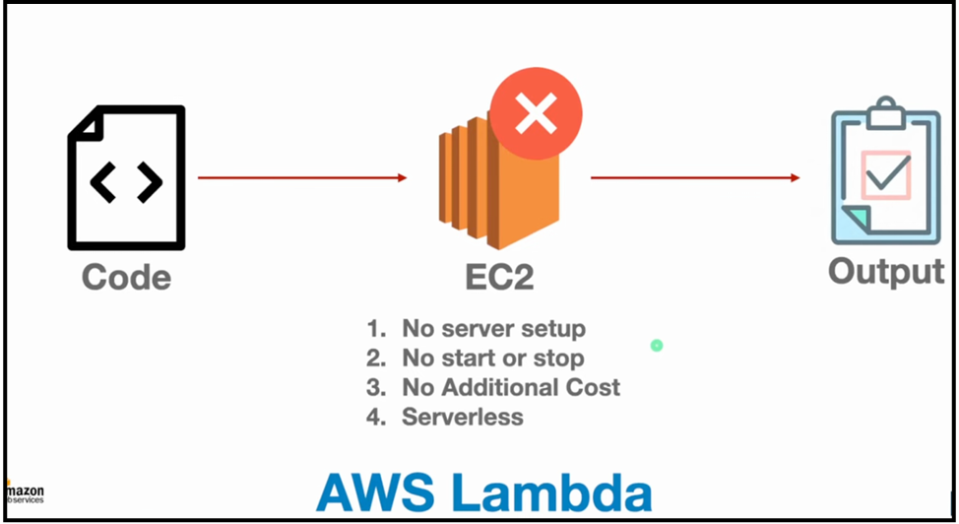

🟡 Key Concepts in Lambda
🔹 1. Functions
The code you upload (Python, Node.js, Go, Java, .NET, Ruby, Custom Runtime)
🔹 2. Events (Triggers)
Something that causes your Lambda to run:
- S3 upload
- API Gateway HTTPS call
- DynamoDB stream
- CloudWatch Cron scheduler
- SNS message
- Event Bridge
- Step Functions
- Kinesis stream
🔹 3. Execution Role
IAM permissions Lambda needs when accessing AWS resources.
🔹 4. Scaling
Lambda automatically runs multiple copies in parallel when traffic increases.
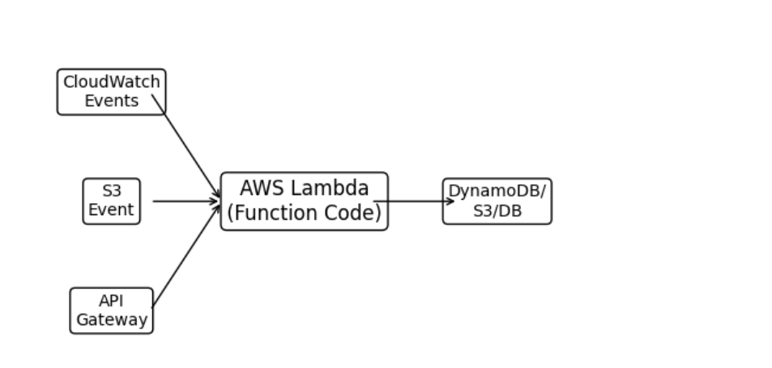
The diagram you see above shows:
- Inputs (Event Sources) → Lambda → Outputs (DB or Storage)
Event examples:
- S3 upload → process image
- API Gateway call → backend API logic
- CloudWatch schedule → cron job
Output examples:
- Store processed data in DynamoDB
- Save logs to CloudWatch
- Push to S3

💡 Example workflow
📌 User uploads a photo to S3
➡️ S3 Event triggers Lambda
➡️ Lambda compresses or labels image
➡️ New version stored in S3
➡️ Store metadata in DynamoDB

Supported Languages
- Python
- Node.js
- Java
- Go
- .NET (C#)
- Ruby
- Custom Runtime

🏷️ Lambda Pricing (Simple)
You pay for:
- Compute time (ms)
- Memory allocated
- Number of requests
Free Tier:
- 1M free requests/month
- 400,000 GB-seconds of compute

⚙️ Lambda Execution Steps (Behind the Scenes)
- Trigger fires
- Lambda picks a container
- Container loads your runtime
- Code is executed
- Output returned
- Cold start (first run) vs warm start (cache)

🏎️ Auto-Scaling Power
If 10,000 people hit your function:
- Lambda creates 10,000 parallel executions
- No configuration required

🔒 Security & IAM
Lambda uses:
- IAM Role
- VPC execution if needed
- Can talk to RDS inside private subnets

🤝 Integrations
Lambda integrates with almost every servers in AWS:
- S3
- SNS
- SQS
- Kinesis
- DynamoDB
- API Gateway
- Step Functions
- Event Bridge
- Auto-scales
- Returns output back to Step Functions

What is API and API gateway?
API = Application Programming Interface
It is a bridge that allows one software system to talk to another.
An API exposes certain functions, data, and operations so other systems can use them.
Simple example:
If we want to know the weather and communicate with Weather app. Our software system connects with Weather app and provides an output.
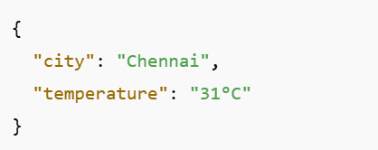
🟡 What is Amazon API Gateway?
AWS API Gateway is a fully-managed service that helps you create, publish, secure, monitor, and scale APIs without managing servers.
Think of it as the front door for your backend systems.
🟣 How API Gateway Works (Simple Flow)
- Client sends HTTP request
e.g. GET /user?id=10
- API Gateway validates request
- Passes request to:
- Lambda
- EC2
- Containers
- Any HTTP endpoint
- Backend generates output
- API Gateway returns formatted response to client
Key Features of AWS Lambda
- No server management
- Automatic scaling
- High availability
- Pay-per-use pricing
- Supports multiple programming languages (Python, Node.js, Java, etc.)

Let’s execute few tasks below.

Task 1- Create a Lambda function
Objective:
The objective of this task is to create a basic Lambda function in AWS.
Prerequisites:
- Lambda
Step by step Implementation:
Step 1: Navigate to Lambda
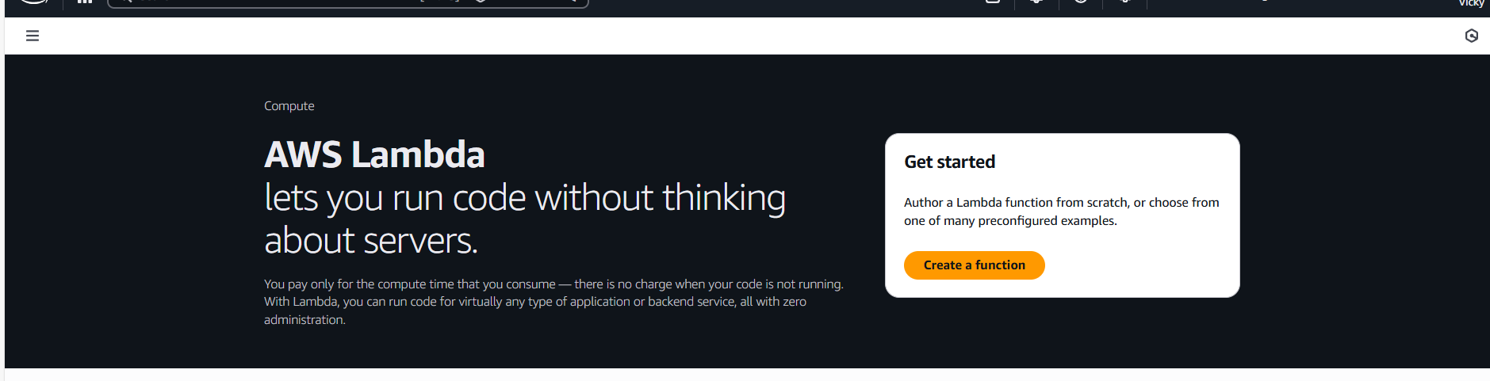
Step 2: Create a function
- Start from Scratch
- Function name- My-Lambda-Function
- Runtime- Python 3.14
- Execution role- Create a new role with Lambda functions
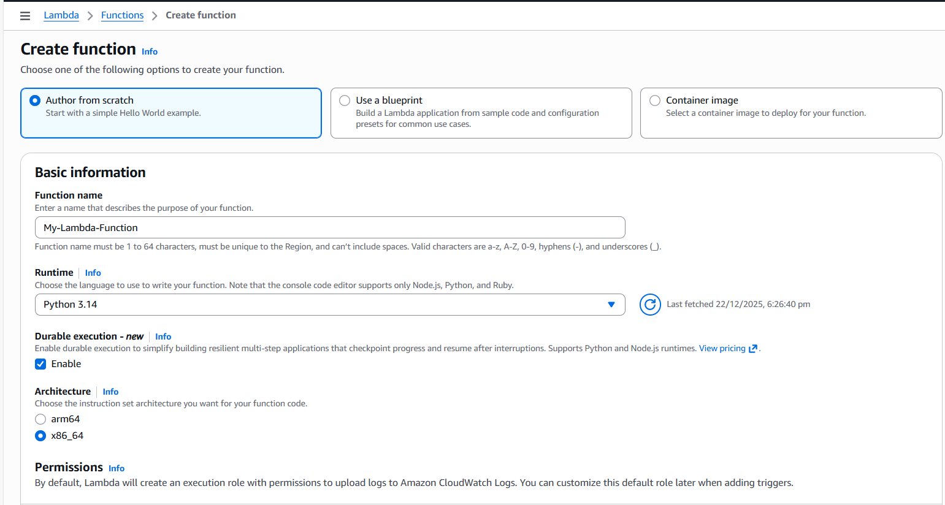
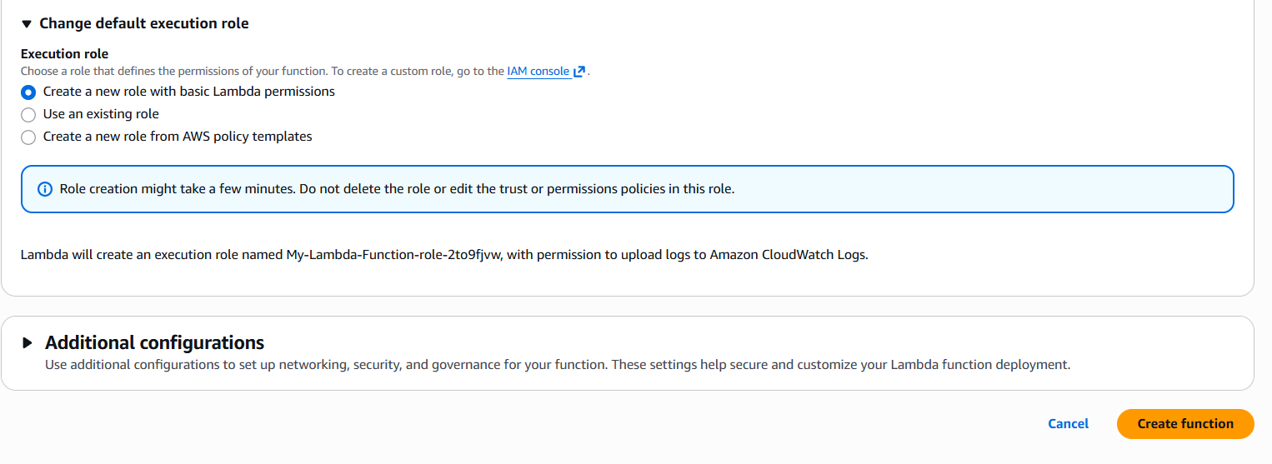
Step 3: Now, we will get a pop up as Getting started.
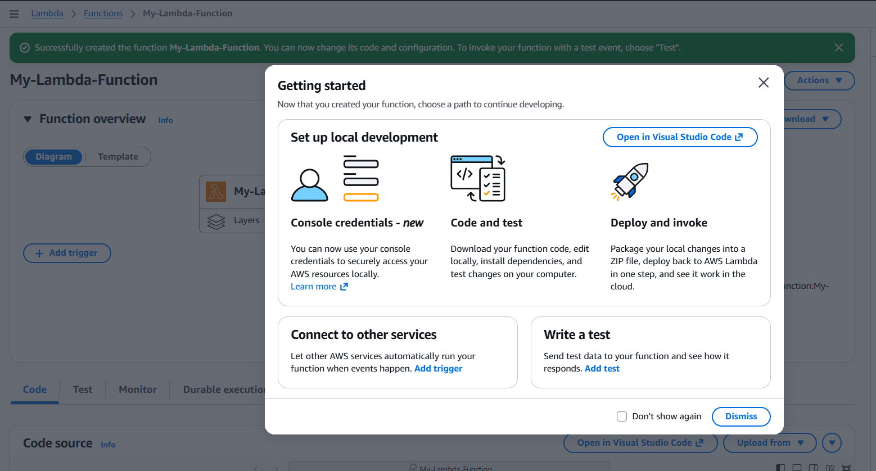
- Our Lambda function is created now.
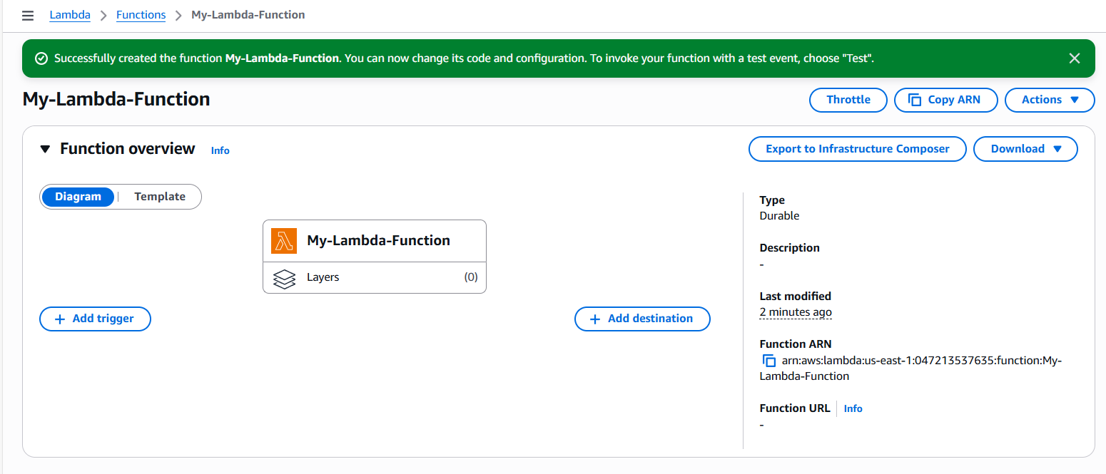
- We replaced the below default code to say- “Hello from Lambda!”

The below is the code.

def lambda_handler(event, context):
return {
"statusCode": 200,
"body": "Hello from Lambda!"
}

- Click Test and Output will be - “Hello from Lambda!”
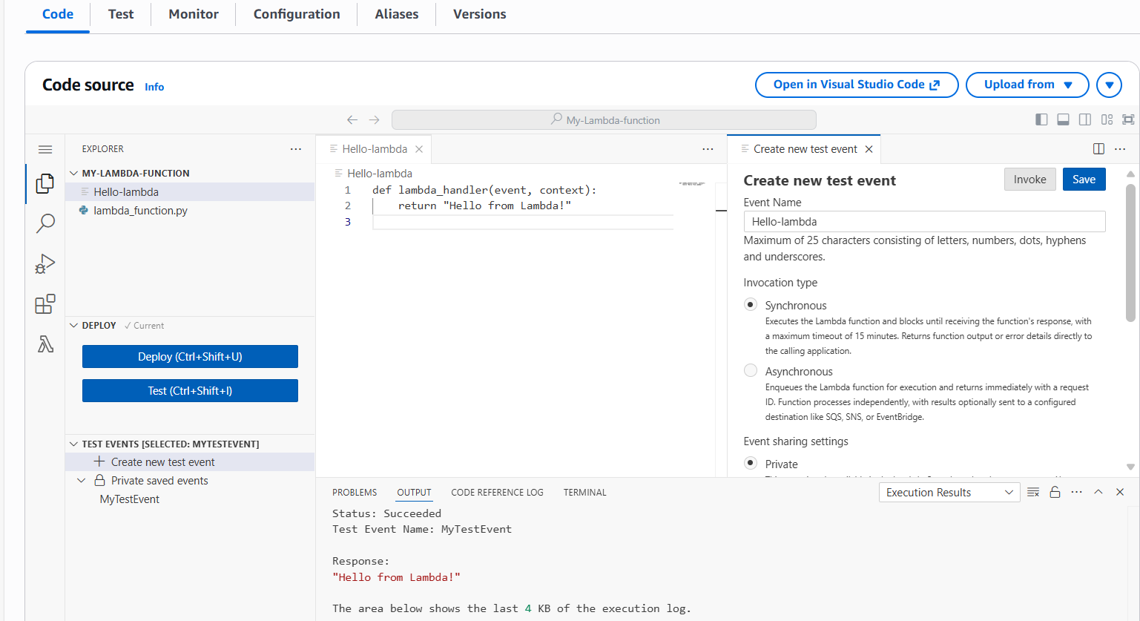

Task 2- Connect Lambda to API Gateway
Objective:
The objective of this task is to call Lamda using browser.
Prerequisites:
- API
- API Gateway
- Lambda
Step by step Implementation:
Step 1: Navigate to API Gateway and create an API
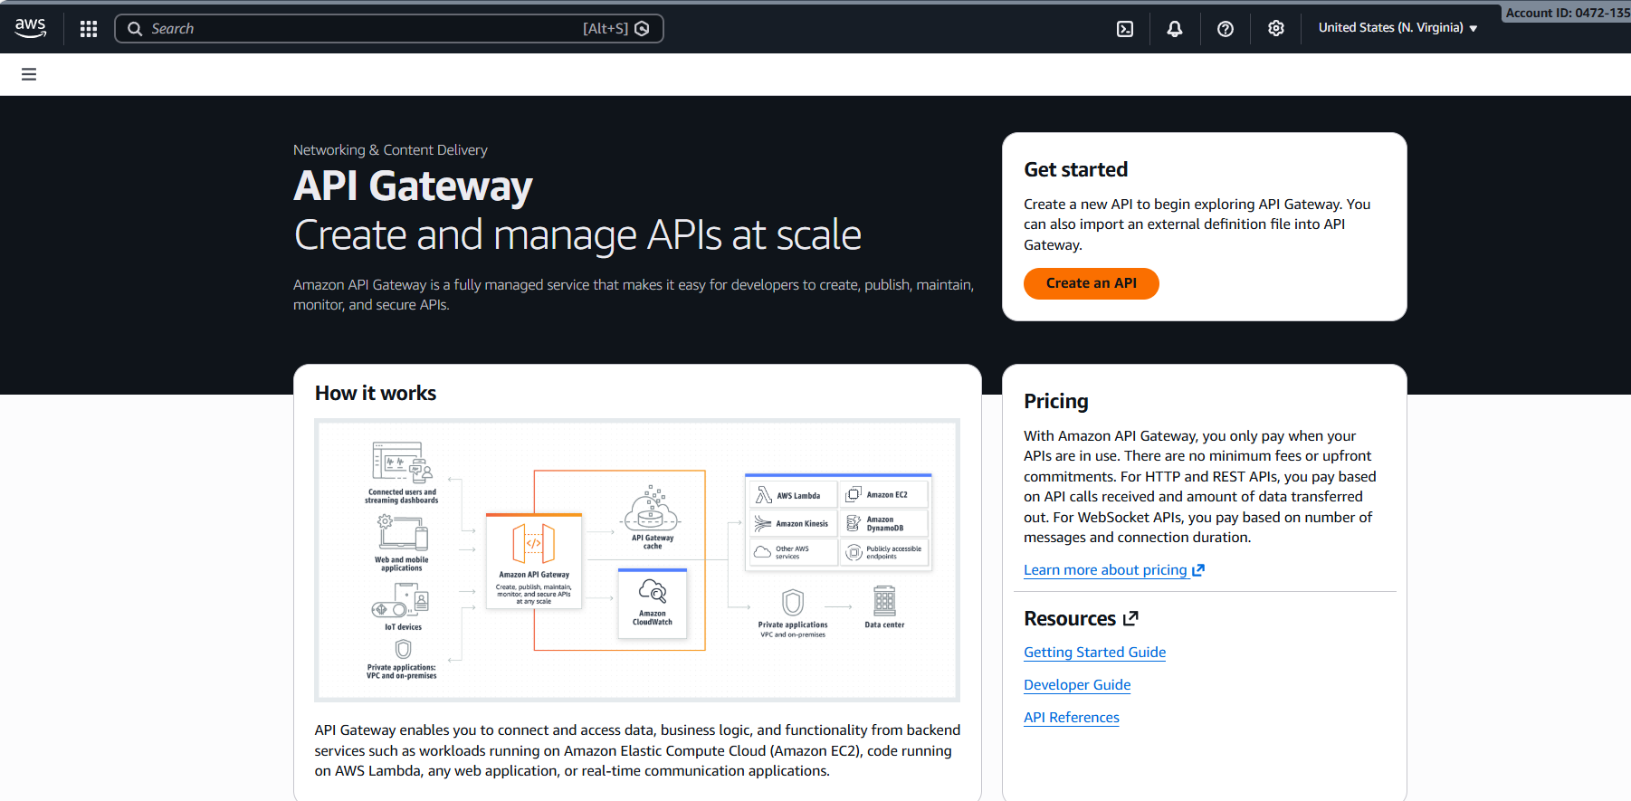
- Build an API using HTTP API
- IP address type- IPV4
- Integrations: Lambda
- Lamda Function: Which we created earlier, attach the function to it and save.
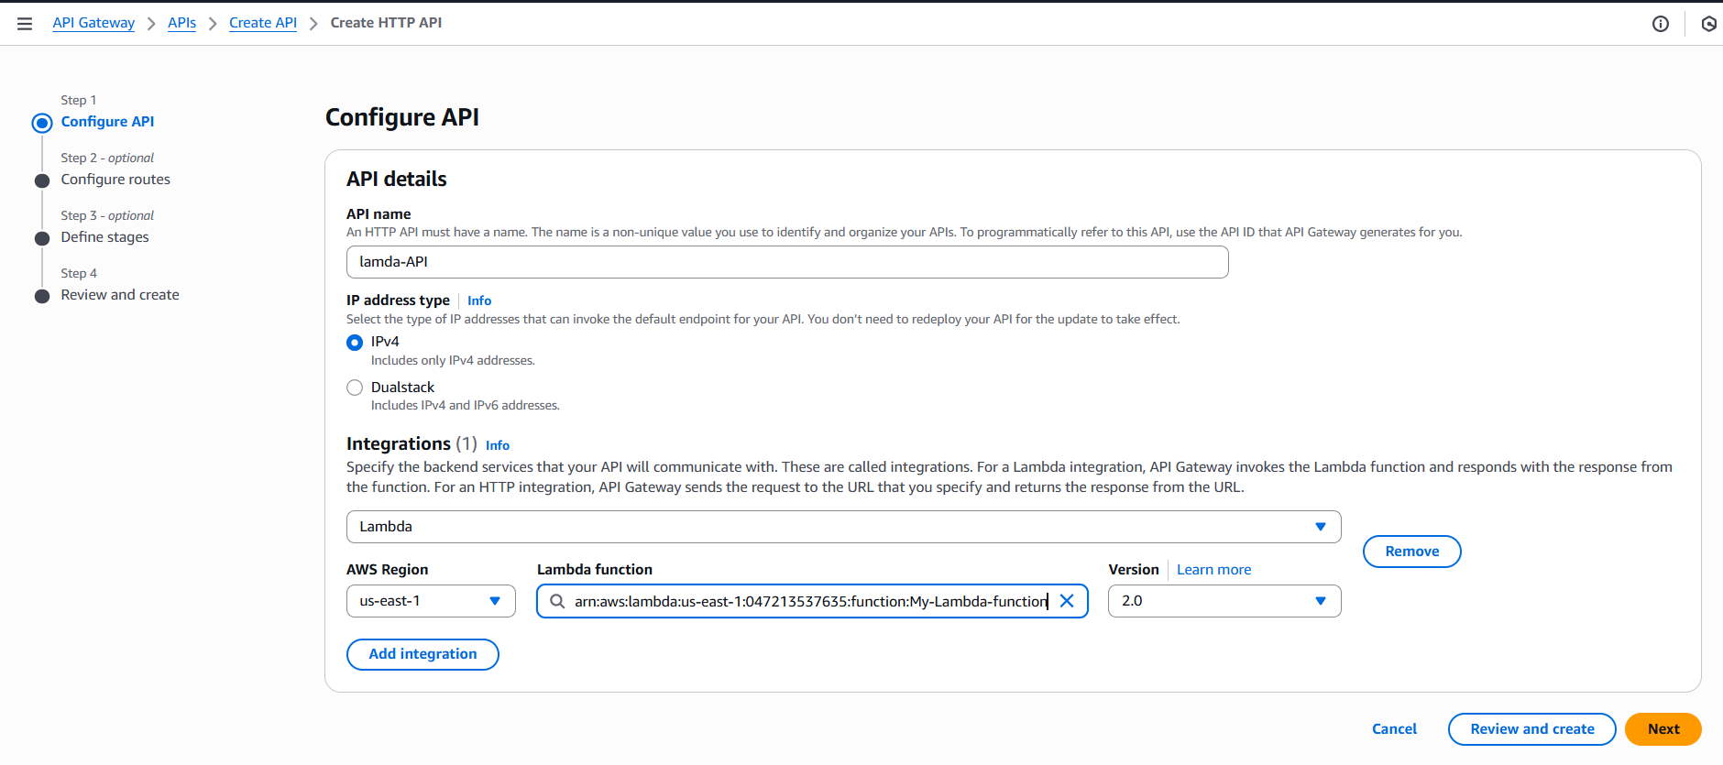
- Configure routes
- Use method- GET
- Resource path- /hello for example
- Integration Target- My-Lambda-function.
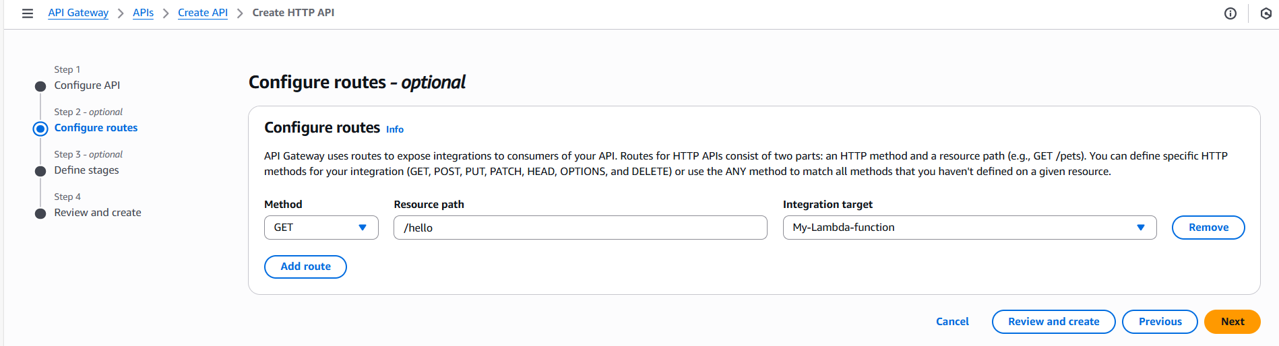
- Review and Create
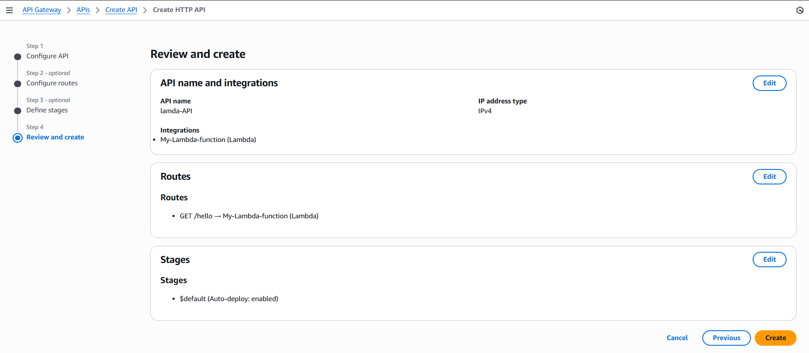

- Successfully created a API Lambda and our HTTP is live.
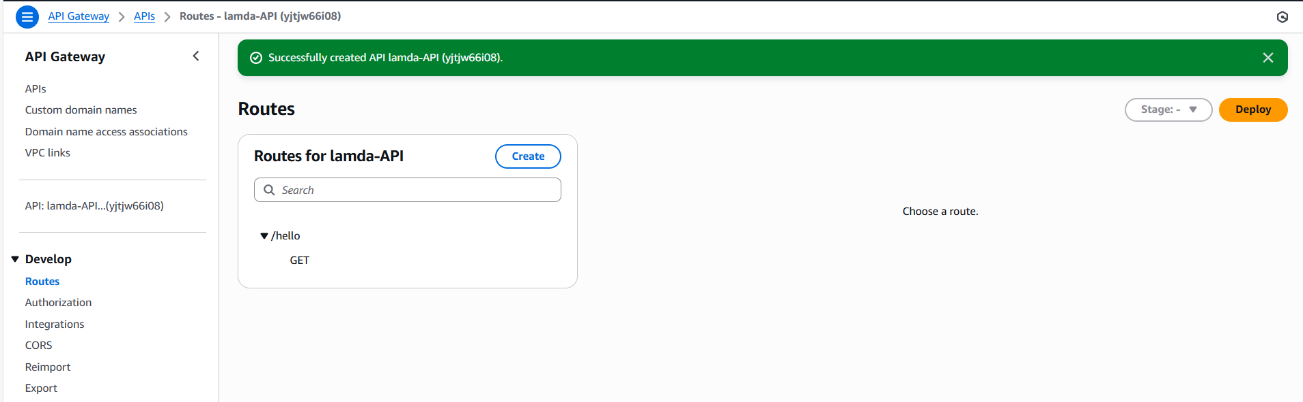
Step 2: Once we created API successfully.
Click the API-Lambda created API and scroll to the stages in the left
Copy the Invoke URL.
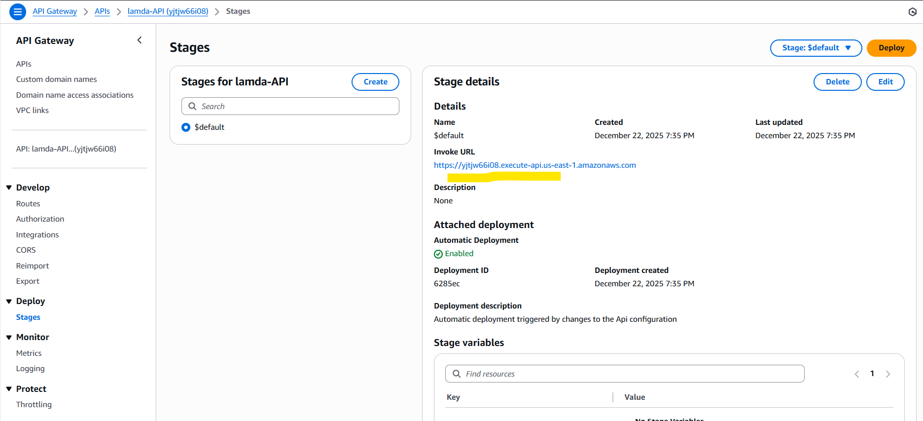

Step 3: Open the browser and add copied <Invoke URL /hello> which we created in the config path.
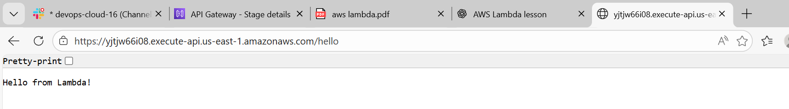
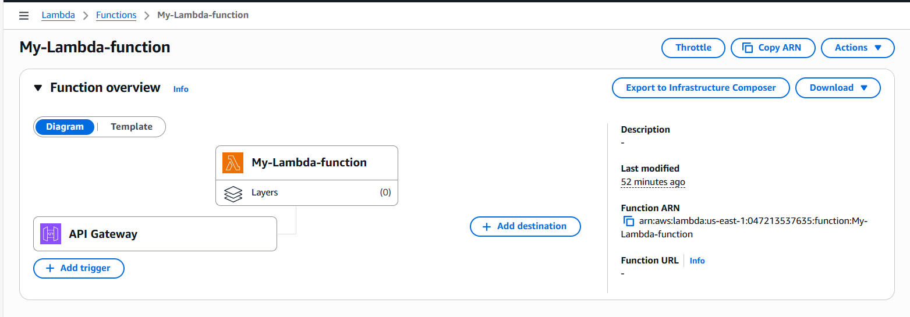

Task complete.

Task 3- We shall add triggers to the CloudWatch
Objective:
The objective of this task is to;
- Enable Monitoring
- Debug Lambda failures
- Where logs are stored
Pre-requisites:
- Lambda
- CloudWatch
Step by step Implementation:
Step 1: Select the API created and click on Add Triggers.
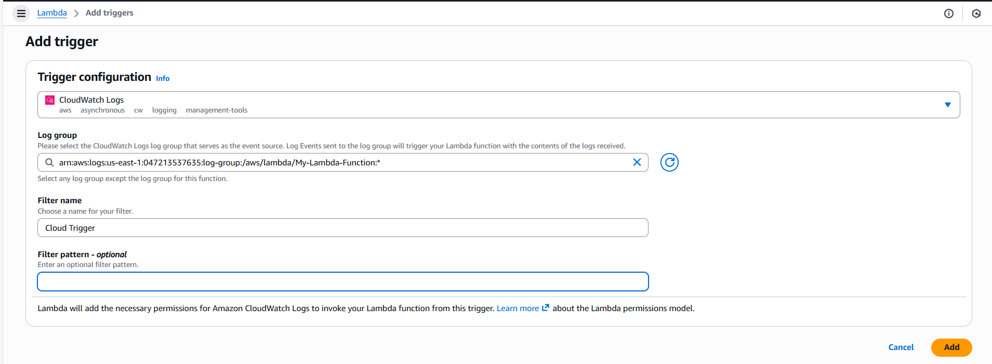
- Trigger has been added to the My-Lambda-fucntion
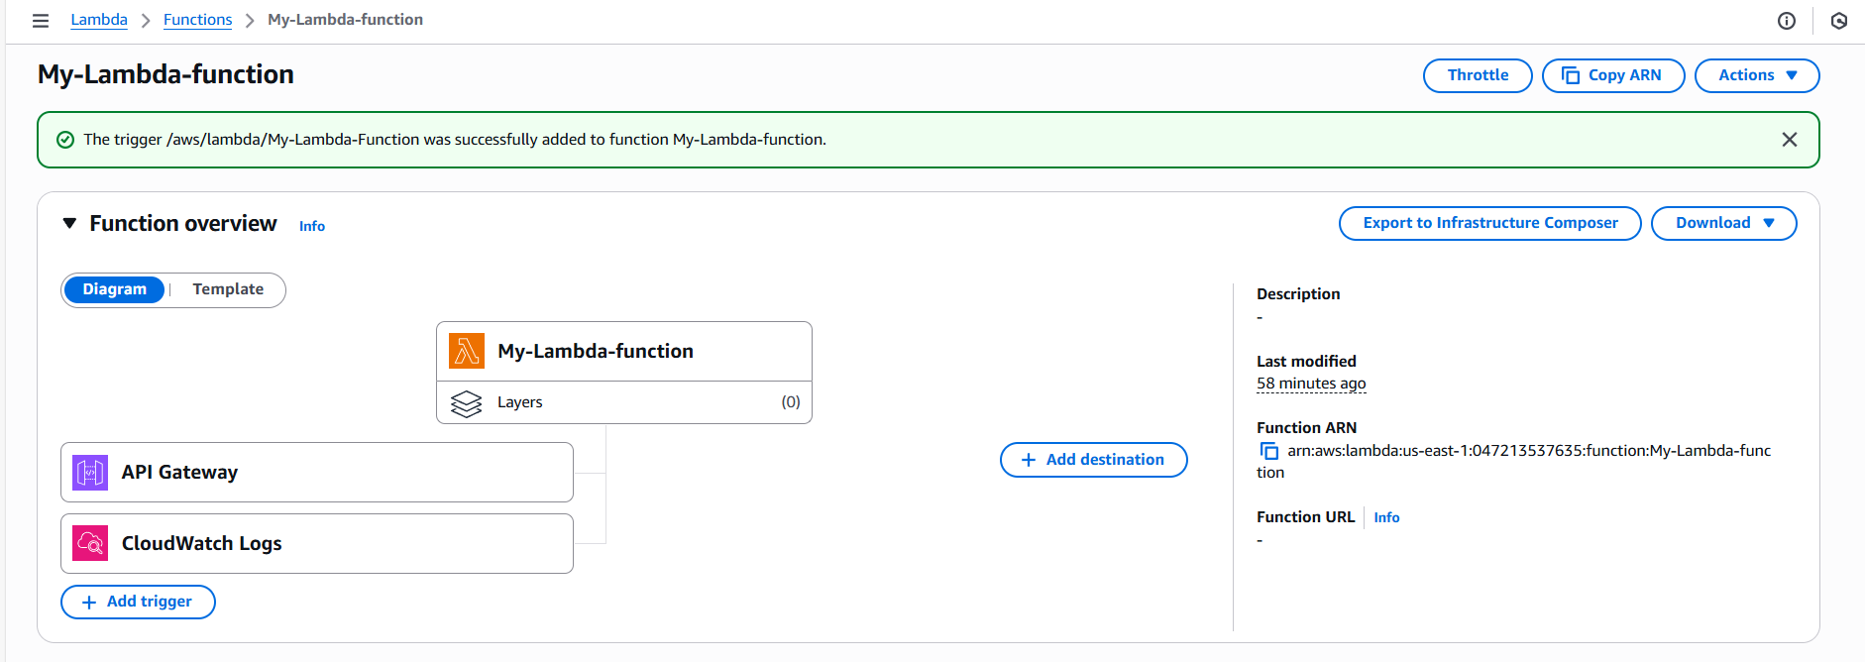

Trigger 2: CloudWatch logs
- Log Group: CloudWatch Logs
- Service Principal: logs.amazonaws.com

  - Now, we will be able to monitor the triggers in CloudWatch logs
  - We will be able to debug the Lambda failures
  - Now, we can find the where the logs are stored.
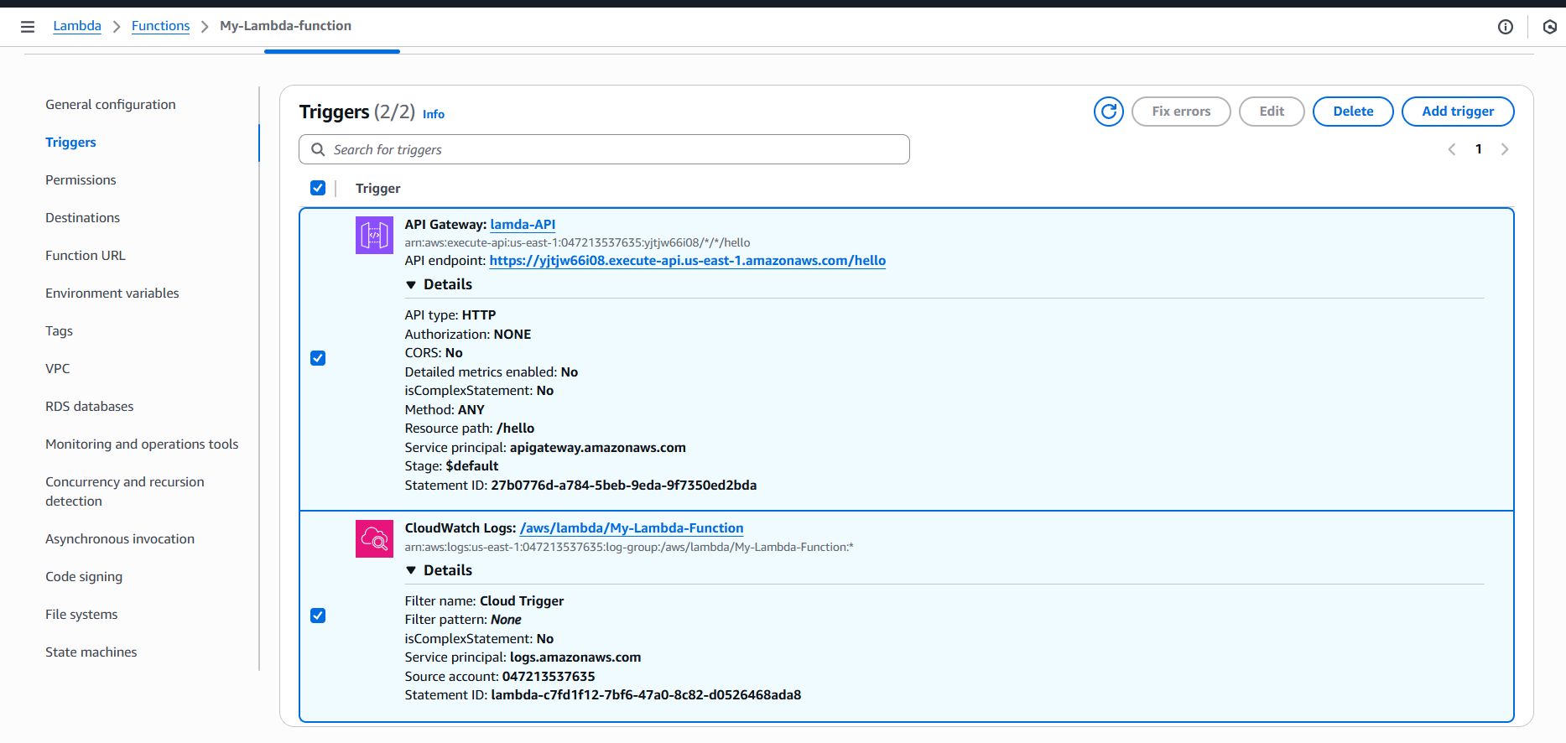

- We Navigated to CloudWatch service and verified under logs.
- Success.
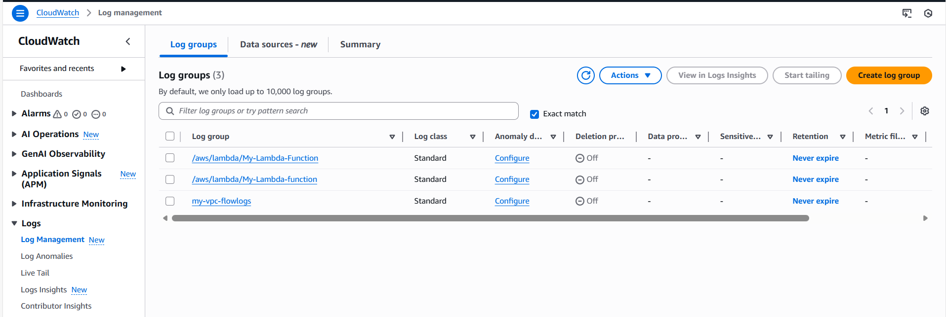

Conclusion:
We created an AWS Function and created a API Gateway
When a user hits the /hello endpoint, API Gateway triggers the Lambda function.
All execution logs are stored in CloudWatch Logs for monitoring.

